**NAME:** JANE PETER

**REG NO.:** CSC/004/2017

**COURSE NAME:** DATABASE SYTEMS

**COURSE CODE:** COM 318

**LECTURER:** MR. NIXONAMUOMO

**DATE SUBMITTED:** 14TH OCTOBER, 2019

Read and prepare summary notes in the following;

Relational system

Relational calculus

Relational algebra

Relational algebra operations with examples

Construct an ER diagram with a set of patients and medical doctors. Associate with each patient a log of various tests in the examinations conducted

**Relation systems**

Refers to a database that stores data in a structured format using rows and columns. This makes it easy to locate and access specific values within the database. It is relational because the values within each table are related to each other. Tables may also be related to other tables. The relational structure makes it possible to run queries across multiple tables.

**Relational structure**

Is a query language which is non-procedural and instead of algebra it uses mathematical predicate calculus. The relational calculus is not the same as that of differential and integral calculus in mathematics but take the name from a branch of symbolic logic termed as predicate calculus. When applied to database it is found in two terms; tuple relational calculus and domain relational calculus.

In first order logic or predicate calculus, a predicate is the truth valid function with arguments. When we replace with values for the arguments the functions yields an expression called proposition which is true or false

**Relational algebra**

Is a procedural query language which takes instances for relations as input and yields instances of relations as output? It uses operators to perform queries. An operator can either be unary or binary. They accept relations as their input and yield relations as their output. A relational algebra is performed recursively on relation and intermediate results are considered relations.

**Relational algebra operations with examples**

**Select operation-p(r)**

It selects tuples that satisfy the given predicate from a relation

**Notation**- where $σ$ stands for selection predicate and **r** stands for relation. P is prepositional logic formula which may use connectors like **and**, **or** and **not.** These terms may use relational operators like -=, ≠, ≥, ≤, >, <.

For example $σsubject=\text{database}(Books)$

**Output**- selects tuples from books where subject is ‘database’

**Project operation ($Π$)**

It projects columns that satisfy a given predicate.

Notation – A1, A2, An(r)

Where A1, A2, An are attribute names of relation r.

Duplicate rows are automatically eliminated as relation as a set.

For example- $Πsubject,author \left(books\right)$

Selects and projects columns named as subjects and author from the relation books.

**Union operation ($∪)$**

It performs binary union between two given relations and is defined as –

r $∪s=\{t|t∈r or t∈s\}$

Notation - r $∪s$

Where r and s are either database relations are relation results set (temporary relation). For a union operation to be valid the following conditions must hold –

R and s must have the same number of attributes

Attribute domains must be compatible

Duplicate tuples are automatically

For example $Π author\left(books∪\right)Π author \left(article\right)$

**Output** – projects the name of the authors who have either written book or an article or both.

**Set difference (-)**

The result of set difference operation is tuples, which are present in one relation but are not on the second relation

**Notation –r-s**

Finds all the tuples that are present in r but not in s

$$Π author\left(books\right)- Π author \left(article\right)$$

**Output-** provides the name of authorswho have written books but not articles

**Cartesian product (x)**

Combines information of two different relations into one.

**Notation – rXs**

Where r and s are relations and their output will be defined as –

*r X s= {q t |q $∈rand t∈$ s}*

$$σauthor=^{'}tutorialspoint^{'}(books X artcles)$$

**Output -** yields a relation, which shows all the books and articles written by tutorials point.

**Rename operation ($ρ$)**

The results of relational algebra are also the relations but without any name. The rename operation allows us to rename the output relation.

**Notation -**x (E)

Where the result of expression E is saved with name of X.

**Construct an ER diagram with a set of patients and medical doctors. Associate with each patient a log of various tests in the examinations conducted**

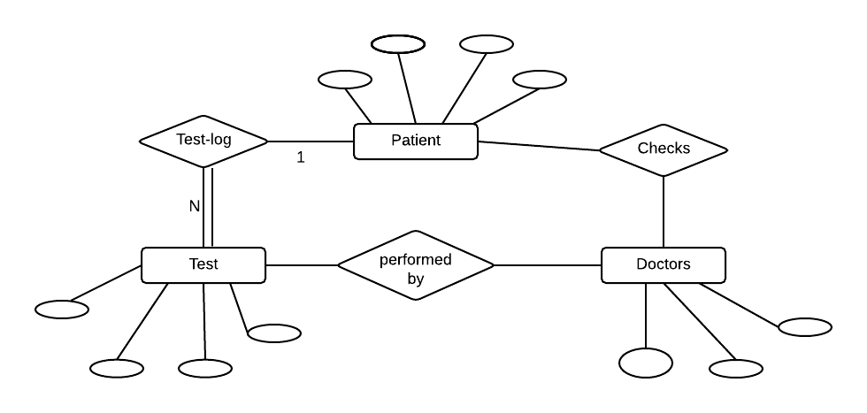

**REFERENCES**

1. An Introduction to Database Systems” by Bipin Desai
2. Database Management Systems” by P S Gill